**Create a react app for Student Management Portal named StudentApp and create a component named Home which will display the Message “Welcome to the Home page of Student Management Portal”. Create another component named About and display the Message “Welcome to the About page of the Student Management Portal”. Create a third component named Contact and display the Message “Welcome to the Contact page of the Student Management Portal”. Call all the three components.**

**Directory:**

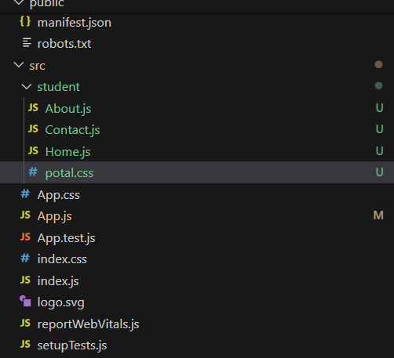

**Code for About.js:**

import React from 'react'

import './potal.css'

const About = () => {

  return (

    <div className='bold-center'>

      Welcome to the About Page of Student Portal

    </div>

  )

}

export default About

**Code for Contact.js:**

import React from 'react'

import './potal.css'

const Contact = () => {

  return (

    <div className='bold-center'>Welcome to the contact page of student portal</div>

  )

}

export default Contact

**Code for Home.js:**

import React from 'react'

import './potal.css'

const Home = () => {

  return (

    <div className='bold-center'>Welcome to the Home page of student portal</div>

  )

}

export default Home

**Code for App.js:**

import logo from './logo.svg';

import './App.css';

import Home from './student/Home';

import About from './student/About';

import Contact from './student/Contact';

function App() {

  return (

<>

<Home />

<About />

<Contact />

</>

  );

}

export default App;

**Code for potal.css:**

.bold-center {

  font-weight: 800;

  display: flex;

  justify-content: center;

  align-items: center;

  text-align: center;

}

**Ouput:**

